On Line Help
The Position box-in function is a quick and easy way to decide the position of a transponder on the seabed in latitude ang longitude. The function requires that you position the transponder with the APOS and that APOS receives the GPS positions of the vessel.

You right click on the transponder symbol, and select the Position Box-in... command in the context sensitive menu. Then the dialog shown below is displayed.

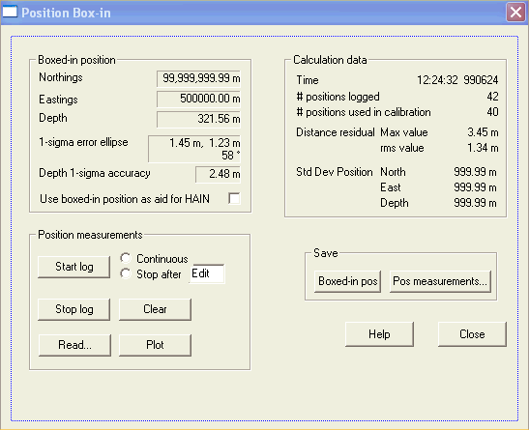

You must start to log measurements by ticking the Start log button. The boxed-in position is automatically recalculated after each measurement.

The dialog contents is grouped in four parts.

Boxed-in position group
It shows the boxed in position together with its error ellipse. The position and the ellipsis data is updated after each measurement.

The error ellipse shows the expected 1-sigma accuracy. The error ellipsis will decrease as the number of measurements increase.

The position that shall be boxed-in, may be position aid for HAIN. Then the Use boxed-in position as aid for HAIN checkbox is displayed. The boxed-in position may be used as position aid for HAIN instead of the measurement itself. This may be done when the HAIN ROV has settled on the seabed for some purpose. Then the operator may start a position box-in of the acoustic position. APOS will use the boxed-in position as position aid for HAIN instead of the measured position. The boxed-in position will be more and more accurate, causing the HAIN estimates to improve. It is very important that the operator stops to use the box-in position before the ROV starts to move again.

Position measurements
This group controls the logging of position measurements.

Start log, Stop log
You must tick the Start log button to start to log measurements. If the radio button Continuous is selected, measurements are logged until you tick the Stop log button. if the Stop after radio button is selected, the logging is stopped after the specified number of measurements.

The Clear button clears the position measurements in memory.

The Plot button generates a plot of the position measurements. If you have logged measurements with more than one round with the Start log button, the positions for each round is displayed with different symbol and colour. The boxed in position is plotted as a star. The Plot function will not be implemented in the first version of Position Box-in.

By ticking the Read... button, a file open dialog is displayed. You can open a file with measurements for the Box-in function that has been saved earlier. These positions may then be plotted again, and you can see the results on the screen.

Calculation data
The Time is when the last measurement was done. The # positions fields show the number of position that are logged and used in the last calculation. The difference between the logged and the used positions tells how many positions that are automatically excluded.

Each position measurement has a distance residual. It is the difference between the boxed-in position and the measurement. The root mean square (rms) and the max of the distance residual is displayed.

The standard deviation in the North, East and Depth directions for the transponder position measurements is shown. The geometrical sum of these three values shall be close to the rms value of the distance residuals.

Save
By ticking the Boxed-in pos button, the calculated boxed-in position is transferred to the latitude longitude values for the transponder object. If the transponder is a location in an LBL array, the position is also transferred to the initial position for the location.

By ticking the Pos measurements... key, you save the measurements to a file. The default file name is PBI_pos_yyyymmddhhmm.txt.
_pos_ identifies the position object, f.ex. _B32_.
_yyyymmddhhmm is the date and time, f.ex. _200507221153.txt.

Advanced information.

Accuracy
The rms of the residuals and the standard deviation of the position measurements reflect the accuracy of the position measurements. These numbers will stabilize as the number of measurements increases. The error ellipsis for the Boxed-in position decrease as the number of measurements increase. Theoretically the error ellipsis of the boxed-in position shall be equal to the standard deviation of the positions divided with the square root of the number of measurements. If the standard deviation is greater, the position measurements are not as accurate as assumed when calculating the error ellipsis, and the error ellipsis is too optimistic.

Transponder box-in versus Transducer alignment
A position error consists of a white part and a coloured part. The white part is gaussian noise that varies randomly from one measurement to the next. The coloured part is usually the same from one measurement to the next. This is the case for a SSBL measurement done from a stationary vessel with constant heading above the transponder. The coloured noise will be reflected neither on the standard deviation nor the rms value.

When the vessel is on top of the transponder, transducer roll and pitch misalignment will give a coloured noise on the measured positions. If you log some measurements, changes the heading 180°, and then log the same number of measurements anew, any roll and pitch misalignment will be detectable. In the plot you will see that the centre of gravity for the measurements with the first heading differs from the centre of gravity for the measurements logged with the next heading. When you log the same number of measurements with the two headings, the errors caused by transducer misalignment will cancel each other, giving a fairly correct boxed-in position. But if such a situation is consistent, you should do a new transducer alignment. You may log the measurements for transducer alignment and transponder box-in simultaneously. If you only log on top of the transponder, you should calculate only the roll and pitch misalignment of the transducer.

